SternerLearn Project Management

Devin Turner and Connor Ledgerwood

# Introduction

For our project management when creating SternerLearn, we used Agilefant software. While we had some problems installing and setting up the Agilefant server, in the end everything worked out and we were able to successfully use it to manage our tasks for the different project iterations and the time allotments for those tasks. It was useful in dividing the work evenly, both between the different iterations and between our group members, and helped keep us on track to complete the project on time.

# Backlogs

We’ll go over the different iterations and the timesheets for each one, and also some screenshots of our Agilefant website. However, for a larger picture, the project was originally planned to complete the web services in the first and second iterations, and then complete the front-end application in the third and fourth iterations. Due to recommendations from the professor and TA, we moved forward our plans. It was fortunate we did, because otherwise we likely would have either been extremely busy the last couple weeks, or ran out of time. In the end, we mostly completed the web services in iteration 1, and then completed the application in iterations 2 and 3. In iteration 4 we did more thorough testing, improvements, and bug fixes.

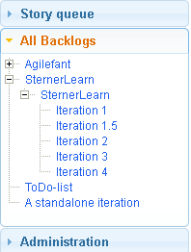

## Iteration 1

For iteration 1, we originally planned on doing about half of the web services. As mentioned above, we ended up doing significantly more. As you can see toward the bottom of this table, many of the tasks from Iteration 2 were completed as part of Iteration 1. This allowed us to begin development on the Android application sooner, which assisted us in completing the project on time.

|  |  |  |  |  |  |  |
| --- | --- | --- | --- | --- | --- | --- |
| Product | Iteration | | | Task | User | Spent effort (hours) |
| SternerLearn | | | Iteration 1 | Create Accounts Database table | Devin Turner | 0.50 |
| SternerLearn | | Iteration 1 | | Create Assignments Database table | Devin Turner | 0.50 |
| SternerLearn | | Iteration 1 | | Create Classes Database table | Devin Turner | 0.50 |
| SternerLearn | | Iteration 1 | | Create Grades Database table | Devin Turner | 0.50 |
| SternerLearn | | Iteration 1 | | Create Infractions Database table | Devin Turner | 0.50 |
| SternerLearn | | Iteration 1 | | Create Iteration 1 Report | Devin Turner | 4.00 |
| SternerLearn | | Iteration 1 | | Create Meta Database table | Devin Turner | 0.50 |
| SternerLearn | | Iteration 1 | | Create Notifications Database table | Devin Turner | 0.50 |
| SternerLearn | | Iteration 1 | | Create Students Database table | Devin Turner | 0.50 |
| SternerLearn | | Iteration 1 | | Create UML documentation | Connor Ledgerwood | 6.00 |
| SternerLearn | | Iteration 1 | | End-to-end testing | Connor Ledgerwood | 6.00 |
| SternerLearn | | Iteration 1.5 | | Create AccountManagement::Login Web Service | Connor Ledgerwood | 4.00 |
| SternerLearn | | Iteration 1.5 | | Create AccountManagement::Register Web Service | Connor Ledgerwood | 4.00 |
| SternerLearn | | Iteration 1.5 | | Create StudentData::addAssignment Web Service | Devin Turner | 2.00 |
| SternerLearn | | Iteration 1.5 | | Create StudentData::addClass Web Service | Devin Turner | 2.00 |
| SternerLearn | | Iteration 1.5 | | Create StudentData::addStudentToClass Web Service | Devin Turner | 2.00 |
| SternerLearn | | Iteration 1.5 | | Create StudentData::addTeacher Web Service | Devin Turner | 2.00 |
| SternerLearn | | Iteration 1.5 | | Create StudentData::getAssignments Web Service | Devin Turner | 2.00 |
| SternerLearn | | Iteration 1.5 | | Create StudentData::getClasses Web Service | Devin Turner | 2.00 |
| SternerLearn | | Iteration 2 | | Create StudentData::addGrade Web Service | Devin Turner | 2.00 |
| SternerLearn | | Iteration 2 | | Create StudentData::addGuardian Web Service | Connor Ledgerwood | 2.00 |
| SternerLearn | | Iteration 2 | | Create StudentData::addInfraction Web Service | Devin Turner | 1.00 |
| SternerLearn | | Iteration 2 | | Create StudentData::getGrades Web Service | Devin Turner | 2.00 |
| SternerLearn | | Iteration 2 | | Create StudentData::getInfractions Web Service | Devin Turner | 1.00 |
| SternerLearn | | Iteration 2 | | Create StudentData::getParentID Web Service | Devin Turner | 1.00 |
| SternerLearn | | Iteration 2 | | Create StudentData::getStudentID Web Service | Devin Turner | 1.00 |

## Iteration 2

For iteration 2, we completed the web service work and began work on the Android application. We hit one large road block in this iteration, which can be seen in the task which consumed the largest amount of time: deploying the database to the cloud instance. This delayed us at least two weeks because we could not begin any web service functionality from the Android application until the web service was deployed. Because of this, we instead began research into the Android platform. Connor did research on the features required for parental control, and Devin began the initial UI work to create the skeleton for the application, from which the web services would later be called.

|  |  |  |  |  |  |
| --- | --- | --- | --- | --- | --- |
| Product | Iteration | Task | User | Spent effort (hours) | |
| SternerLearn | Iteration 2 | Android GPS access research | Connor Ledgerwood | | 4.00 |
| SternerLearn | Iteration 2 | Android root access research | Connor Ledgerwood | | 4.00 |
| SternerLearn | Iteration 2 | Android text messages research | Connor Ledgerwood | | 4.00 |
| SternerLearn | Iteration 2 | Create ParentalManagement::addLocation Web Service | Devin Turner | | 1.00 |
| SternerLearn | Iteration 2 | Create ParentalManagement::getLocations Web Service | Devin Turner | | 1.00 |
| SternerLearn | Iteration 2 | Create web page to conveniently display database tables while on the cloud instance | Devin Turner | | 2.00 |
| SternerLearn | Iteration 2 | Deploy database to cloud instance | Connor Ledgerwood | | 15.00 |
| SternerLearn | Iteration 2 | End-to-end testing | Devin Turner | | 1.00 |
| SternerLearn | Iteration 2 | End-to-end testing | Connor Ledgerwood | | 1.00 |
| SternerLearn | Iteration 3 | Create Base page with Login/Register buttons | Devin Turner | | 3.00 |
| SternerLearn | Iteration 3 | Create Login page | Devin Turner | | 4.00 |
| SternerLearn | Iteration 3 | Create Register page | Devin Turner | | 3.00 |
| SternerLearn | Iteration 3 | Create main account page | Devin Turner | | 4.00 |

## Iteration 3

This was the most time consuming iteration. Due to recommendations from the professor and TA, we attempted to nearly complete the application, and succeeded. However, considering the point at which we were left off in Iteration 2, this meant creating nearly the whole front-end application from scratch. We spent about twice as long on this iteration as we did on Iteration 2, and created virtually the whole front-end application. This included both the UI work and adding in calls to retrieve the data to display to the user.

|  |  |  |  |
| --- | --- | --- | --- |
| Project | Task | User | Spent effort (hours) |
| SternerLearn | Create Add Class page | Devin Turner | 3.00 |
| SternerLearn | Create Add Grade page | Devin Turner | 3.00 |
| SternerLearn | Create Add Infraction page | Devin Turner | 4.00 |
| SternerLearn | Create Add Student to Class page | Devin Turner | 4.00 |
| SternerLearn | Create Assignments list page | Devin Turner | 6.00 |
| SternerLearn | Create Classes page | Devin Turner | 4.00 |
| SternerLearn | Create GPS Receiver service | Connor Ledgerwood | 8.00 |
| SternerLearn | Create Grades page | Devin Turner | 6.00 |
| SternerLearn | Create Link Accounts page | Connor Ledgerwood | 6.00 |
| SternerLearn | Create SMS Receiver service | Connor Ledgerwood | 6.00 |
| SternerLearn | Create Text Messages list page | Connor Ledgerwood | 8.00 |
| SternerLearn | Create UML documentation | Connor Ledgerwood | 4.00 |
| SternerLearn | Create additional web services that were required | Devin Turner | 2.00 |
| SternerLearn | Create additional web services that were required | Connor Ledgerwood | 2.00 |
| SternerLearn | Create main account page | Devin Turner | 2.00 |
| SternerLearn | Create report | Devin Turner | 4.00 |
| SternerLearn | Create report | Connor Ledgerwood | 4.00 |
| SternerLearn | Create teachers' Class list page | Devin Turner | 4.00 |
| SternerLearn | End-to-end testing | Devin Turner | 8.00 |
| SternerLearn | End-to-end testing | Connor Ledgerwood | 8.00 |

## Iteration 4

At this point the application was almost complete functionally. We wrapped up the remaining pages, but this did not take too much time. Afterward we did a significant amount of testing, improvements, and in particular visual improvements. We changed the theme, added a new icon, improved some page layouts, and more. Then, finally, we completed the video presentation for our project. While we still spent a large amount of work in this iteration, it was almost relaxation compared to the previous one.

|  |  |  |  |
| --- | --- | --- | --- |
| Project | Task | User | Spent effort (hours) |
| SternerLearn | Create SMS Receiver service | Connor Ledgerwood | 2.00 |
| SternerLearn | Add page titles | Devin Turner | 2.00 |
| SternerLearn | Adding Toasts to Teacher pages | Devin Turner | 3.00 |
| SternerLearn | Bug fixing | Devin Turner | 3.00 |
| SternerLearn | Completing full functionality of all pages from Iteration 3 | Devin Turner | 12.00 |
| SternerLearn | Create Iteration 4 report | Devin Turner | 4.00 |
| SternerLearn | Create Iteration 4 report | Connor Ledgerwood | 4.00 |
| SternerLearn | Create Tracking Location page | Connor Ledgerwood | 12.00 |
| SternerLearn | Create video presentation | Devin Turner | 4.00 |
| SternerLearn | Create video presentation | Connor Ledgerwood | 8.00 |
| SternerLearn | End-to-end testing | Devin Turner | 4.00 |
| SternerLearn | End-to-end testing | Connor Ledgerwood | 4.00 |
| SternerLearn | Refactoring code | Devin Turner | 6.00 |
| SternerLearn | Store login information across sessions | Devin Turner | 6.00 |
| SternerLearn | Visual improvements | Connor Ledgerwood | 2.00 |
| SternerLearn | Visual improvements | Devin Turner | 4.00 |

## Conclusion

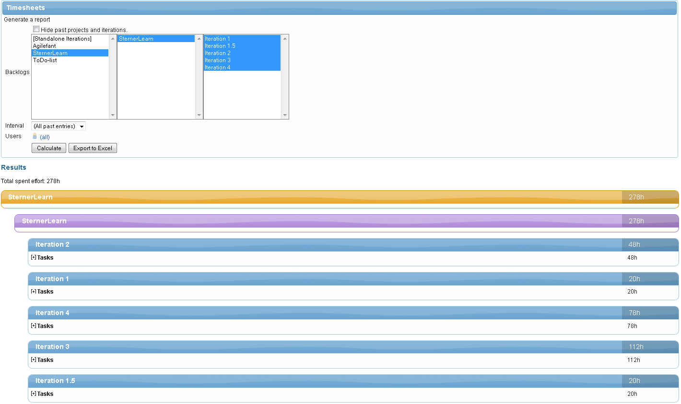Overall we devoted a significant amount of work toward our project, SternerLearn. But in the end, we’re happy with where it ended and with the work we did as a team. Together we spent 278 hours working on this application, learning C#, ASP.NET, Java, Android APIs, Google Map APIs, and had a completed product at the end of it.

## Deployment

Our agilefant website information access can be seen below.

<https://cloud.agilefant.org/dfturn/login.jsp>

To log in, use the username “professor” and password “password”.